8.82: Even though one of the masses is not known, the analysis of Section (8.4) leading to Eq. (8.26) is still valid, and b) The mass 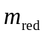 may be found from either energy or momentum considerations. From momentum conservation,
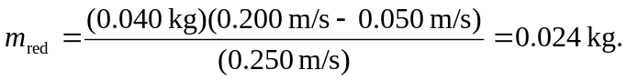
As a check, note that

